Department of Computer Science and Engineering
The University of Texas at Arlington

Team: The Builders Group Ltd.
Project: Sliding Profiler
Team Members:
Chudamani Aryal
Jefferson White
Tyler Buchanan
Lloyd Bond

Last Updated: 7/16/2012 3:17 PM

Table of Contents
Table of Contents 2
Document Revision History 7
List of Figures 8
List of Tables 9
1. Product Concept 10
1.1 Purpose and Use 10
1.2 Intended Audience 10
2. Product Description and Functional Overview 11
2.1 Features and Functions 11
2.2 External Inputs and Outputs 12
2.3 Product Interfaces 12
3. Customer Requirements 14
3.1 The device must turn on/off easily 14
3.2 The device shall not operate after a critical error 14
3.3 The device shall visually indicate error conditions 14
3.4 The device shall visually indicate when it is operating normally 15
3.5 The device shall be able to measure the travel distance of the platform 15
3.6 The device shall be able to measure the inclination of the platform from a calibration point 15
3.7 The device shall generate operational data from the raw data of the sensors 16
3.8 The device shall transfer operational data to the client application in real-time 16
3.9 The device shall detect bumps in concrete pavement while the product is floating on the freshly poured concrete surface 16
3.10 The device shall be able to operate in extreme temperatures 17
3.11 The device shall be able to measure the internal temperature of the electronics housing 17
3.12 The device shall use an embedded PIC microcontroller w/ networking 17
3.13 The device shall store operational data 18
3.14 The electronics housing shall be easy to clean 18
3.15 The electronics shall be detachable from the Platform 18
3.16 The platform shall attach to the road paver 19
3.17 The platform shall be easy to clean 19
3.18 The client application must run on a PC 19
3.19 The client application shall display operational data 19
3.20 The client application shall read stored data 20
3.21 The client application shall calibrate sensors 20
3.22 The client application shall configure the PIC microcontroller 20
3.23 The configuration process shall be abstracted from the end-user 21
3.24 The product shall have a user-friendly client application 21
3.25 The product shall come with a storage solution 21
3.26 The product shall be able to operate in a stand-alone mode 22
3.27 The product shall visually indicate a bump using a beacon light 22
3.28 The product shall be light enough to float on top of the concrete pavement 22
3.29 The product shall have GPS to track the bump location 22
4. Packaging Requirements 24
4.1 Software 24
4.2 Hardware 24
4.3 Electronic Housing 24
5. Performance Requirements 26
5.1 The device shall perform in real-time 26
5.2 The device power source shall be provided externally 26
5.3 The product shall not disturb the wet concrete 26
5.4 The slider shall not accumulate cement 27
5.5 The system shall store operational data 27
5.6 The stored data shall be accessible by user 27
5.7 The product shall operate in extreme temperatures 28
5.8 The client application shall receive data in real time when connected to the device 28
6. Safety Requirements 29
6.1 The product shall have a power source interruption 29
6.2 The product shall have no sharp edges 29
6.3 The product shall have an electric shock protection 29
7. Maintenance and Support Requirements 31
7.1 The product shall be easy to clean 31
7.2 The product shall be returned to the supplier after a critical malfunction 31
7.3 The product shall come with a support manual 31
7.4 Team TBGL shall not support software and hardware issues after the completion of project 32
8. Other Requirements 33
9. Acceptance Criteria 34
9.1 Verify the device is easily turned on/off 34
9.2 Verify the device shall not operate after critical error 34
9.3 Verify the device visually indicates an error condition 34
9.4 Verify the device visually indicates normal operations 34
9.5 Verify the device measures distance of the platform 35
9.6 Verify the device measures inclination from a calibrated point 35
9.7 Verify the device generates operational data 35
9.8 Verify the device transfers data in real-time 35
9.9 Verify the device detects bumps 36
9.10 Verify the device can stand extreme temperatures 36
9.11 Verify the device measures internal temperature 36
9.12 Verify the device uses an embedded PIC w/ Ethernet 37
9.13 Verify the device stores operational data 37
9.14 Verify the electronic housing is easy to clean 37
9.15 Verify the electronics are detachable from the platform 37
9.16 Verify the device is attachable to the road paver 37
9.17 Verify the platform is easy to clean 38
9.18 Verify the application runs on a PC 38
9.19 Verify the application shall display operational data 38
9.20 Verify the application reads stored data 38
9.21 Verify the application calibrates sensors 38
9.22 Verify the application configures the PIC 39
9.23 Verify the configuration is abstracted from the user 39
9.24 Verify the application is user friendly 39
9.25 Verify the device includes a storage solution 39
9.26 Verify the system shall be able to operate in a stand-alone mode 40
9.27 Verify the device visually signals when a bump is detected by light 40
9.28 Verify the device can float atop concrete pavement 40
9.29 Verify the device uses GPS tracking 40
10. Use Cases 41
10.1 Device setup and installation 41
10.2 User calibrates the product 41
10.3 User configures product 42
10.4 User retrieves data from the product 42
10.5 User cleans the product 43
11. Feasibility Assessment 44
11.1 Scope Analysis 44
11.2 Research 44
11.3 Technical Analysis 44
11.4 Cost Analysis 45
11.5 Resource Analysis 48
11.6 Schedule Analysis 48
12. Future Items 51
12. 1 The operator shall be able to run diagnostics test from client application 51
12. 2 The System shall have help option 51

Document Revision History
Revision Number | Revision Date | Description | Rationale
0.1 | 7/17/2012 | Rough Draft | Submission to Professor O’Dell
1.0 | 7/23/2012 | Second Draft | Gate Review
2.0 | 8/3/2012 | Final Draft | Baseline SRD

List of Figures
Figure # Title Page #
1-1 Rear view of a typical paver 10
2-1 Pictorial Description 11
2-2 Product Function 11
2-3 User Hardware Interface 12
2-4 Software User Interface 13
10-1 Use Case: Enable/disable power 40
10-2 Use Case: Calibrate Product 41
10-3 Use Case: Configure product 41
10-4 Use Case: Data retrieval 42
10-5 Use Case: Cleaning product 42

List of Tables
Figure # Title Page #
11-1 Case 1: Cost Analysis 45
11-2 Case 2: Cost Analysis 45
11-3 Software Project Size and Productivity Approach 45
11-4 Rule Of Thumb 46
11-5 CoCoMo – nominal, Semi-detached 46
11-6 Comparison of various estimation methods 47

1. Product Concept
This section describes the purpose, use and intended user audience for the Sliding Profiler product. The Sliding Profiler is a wet concrete bump detection product that aggregates data from many sensors to determine the probable smoothness of the freshly laid road. Before the concrete has dried, the operators will know if the concrete has met the state requirement for smoothness of concrete roads.

Purpose and Use
The Sliding Profiler will use various sensors to determine if the freshly poured concrete has any bumps unfit for vehicular travel. Our expectations are the Sliding Profiler will follow a cement spreader detecting inclination and distance, and then notify concrete smoothers of detected bumps to be smoothed.

Intended Audience
The Sliding Profiler will benefit construction contractors who specifically specialize or intend to build concrete highway or road. The Sliding Profiler will need to be made available commercially.
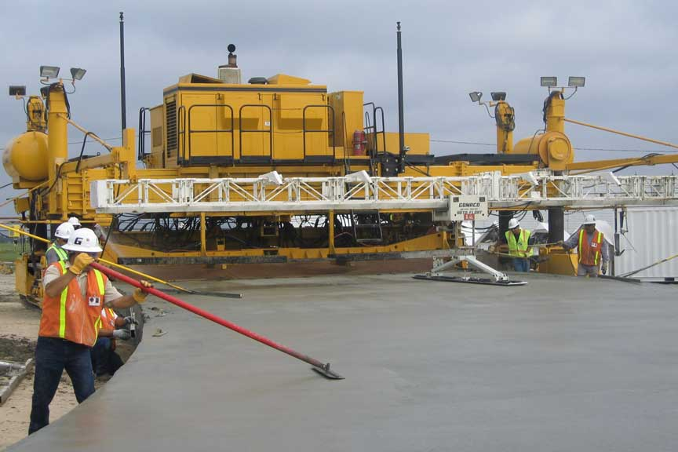
Figure 1-1 Rear view of a typical paver

2. Product Description and Functional Overview
This section provides the reader with an overview of the Sliding Profiler. The primary operational aspects of the product, from the perspective of end users, maintainers and administrators, are defined here. The key features and functions found in the product, as well as critical user interactions and user interfaces are described in detail.
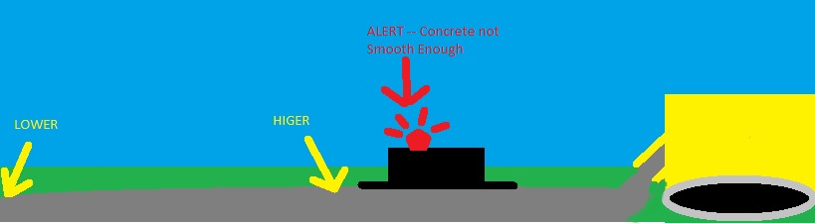
Figure 2-1 Pictorial Description

2.1 Features and Functions
The Sliding Profiler will be built on a flat smooth base, possibly something like a snowboard or wake board. The entire product will be light enough to float on wet concrete with minimal disruption. There will be an attached distance wheel for tracking distance traveled, coupled with an inclinometer to sense changes in concrete height. Gathered data will be processed and transmitted to a client machine for reviewing the processed data (e.g. the location of the bumps) and pure raw data analysis.
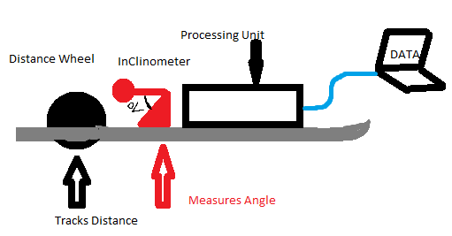
Figure 2-2 Product Function

2.2 External Inputs and Outputs
The Sliding profiler will have minimal inputs and outputs and low user interaction. The user will first turn on the device. At this point the device will be self-contained and begin to collect data, to which the product will analyze. If a bump is detected, a warning light will flash. To ensure device hasn’t failed, a heartbeat light will flash periodically as part of the execution of data analyzed. The User will be able download the raw and processed data for personally analysis via a User UI.
ITEM | Description | Use | Input or Output
ON/OFF | Turns on and off | Turns on and off | INPUT
USER UI | Software Application | View analyzed and processed data | OUTPUT
Warning Light | A bright flash able light | Notify a bump is detected | OUTPUT
Heart Beat | A soft flashing light | Notify continuous operation | OUTPUT

2.3 Product Interfaces
Figure 2-3 User Hardware Interface
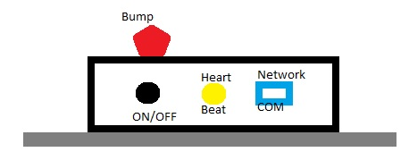
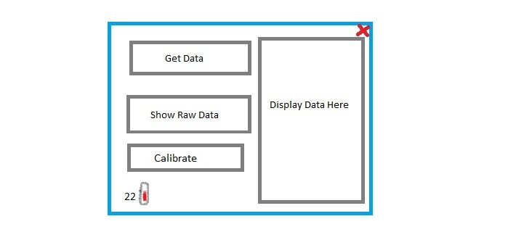
Figure 2-4 Software User Interface

3. Customer Requirements
This section describes the features and functions required/specified/expected by the customer. This is what customer should minimally expect from the product. Most of these requirements are collected from our project sponsor Dr. Roger Walker. Although there was no involvement of a probable customer when collecting these requirements, they are intended to satisfy the customers need. Great deal of care must be taken to finalize these requirements, and must not be changed without the agreement of project sponsor. The product is divided into three components: (i) the client application, (ii) the platform, and (iii) the electronic device.

3.1 The device must turn on/off easily

3.1.1 Description: The device shall be able to turn on and off. The operator shall turn on/off the device from the client application by pressing on/off button.

3.1.2 Source: Dr. Roger Walker

3.1.3 Constraints: Turning off of the device should not damage the data stored in the device.

3.1.4 Standards: N/A

3.1.5 Priority: High

3.2 The device shall not operate after a critical error

3.2.1 Description: It is not certain that all the electronics devices last for a long time. From time to time, they encounter various problems and errors. If the errors are critical, it is necessary to deal with it properly. So once the critical errors are encountered, the device shall save all the necessary data and shut down. Qualified technicians have to be called to fix those critical errors.

3.2.2 Source: Dr. Roger Walker

3.2.3 Constraints: Turning off of the device should not damage the data stored in the device.

3.2.4 Standards: N/A

3.2.5 Priority: Critical

3.3 The device shall visually indicate error conditions

3.3.1 Description: The device shall provide a visual indication that there is an error in the device. Only experienced users and technicians shall be allowed to repair the device.

3.3.2 Source: Dr. Roger Walker

3.3.3 Constraints: N/A

3.3.4 Standards: N/A

3.3.5 Priority: High

3.4 The device shall visually indicate when it is operating normally

3.4.1 Description: Once the device is in use and there are no errors, the device shall provide a visual indication that the device is operating normally.

3.4.2 Source: Dr. Roger Walker

3.4.3 Constraints: N/A

3.4.4 Standards: N/A

3.4.5 Priority: High

3.5 The device shall be able to measure the travel distance of the platform

3.5.1 Description: In order to measure a bump in the concrete pavement, it is extremely important to measure the distance accurately. The distance encoder shall be kept in order to track the distance traveled.

3.5.2 Source: Dr. Roger Walker

3.5.3 Constraints: N/A

3.5.4 Standards: N/A

3.5.5 Priority: Critical

3.6 The device shall be able to measure the inclination of the platform from a calibration point

3.6.1 Description: According to the algorithm devised by Dr. Roger Walker, in order to measure a bump in the concrete pavement, it is also extremely important to accurately measure the inclination of the platform from a calibration point.

3.6.2 Source: Dr. Roger Walker

3.6.3 Constraints: N/A.

3.6.4 Standards: N/A

3.6.5 Priority: Critical

3.7 The device shall generate operational data from the raw data of the sensors

3.7.1 Description: Once the raw data has been collected from the sensor, it shall be converted into operational data with the help of A/D converter. The data is required to calculate and detect bumps in concrete pavement.

3.7.2 Source: Dr. Roger Walker

3.7.3 Constraints: N/A

3.7.4 Standards: N/A

3.7.5 Priority: Critical

3.8 The device shall transfer operational data to the client application in real-time

3.8.1 Description: Since all operational data is required by the client application in order to display, it is necessary to transfer this data to the client application.

3.8.2 Source: Dr. Roger Walker

3.8.3 Constraints: N/A

3.8.4 Standards: N/A

3.8.5 Priority: Medium

3.9 The device shall detect bumps in concrete pavement while the product is floating on the freshly poured concrete surface

3.9.1 Description: The algorithm to detect bumps in the concrete pavement was devised by Dr. Roger Walker. The tolerance of the bump detection is determined in the algorithm and specified by Dr. Walker. Dr Walker’s algorithm should meet the smoothness specification of TxDOT. The operational data consists of the accurate measurements of the distance travelled by the platform and the inclination of the platform from a calibration point.

3.9.2 Source: Dr. Roger Walker

3.9.3 Constraints: N/A

3.9.4 Standards: N/A

3.9.5 Priority: Critical

3.10 The device shall be able to operate in extreme temperatures

3.10.1 Description: Since the product is for outdoor use, it is extremely important to consider temperature as one of the biggest factors. The temperature in Texas for road construction ranges from 40 º F to 120 º F. Hence, the device must be able to operate in extreme temperature.

3.10.2 Source: Dr. Roger Walker

3.10.3 Constraints: N/A

3.10.4 Standards: N/A

3.10.5 Priority: Critical

3.11 The device shall be able to measure the internal temperature of the electronics housing

3.11.1 Description: Since the product shall to be able to operate continuously throughout the day, the product might overheat. Hence, it is extremely important to keep track of the internal temperature and perform some operation to minimize the heat.

3.11.2 Source: Dr. Roger Walker

3.11.3 Constraints: N/A

3.11.4 Standards: N/A

3.11.5 Priority: High

3.12 The device shall use an embedded PIC microcontroller w/ networking

3.12.1 Description: It was requested by Dr. Walker to use a PIC microcontroller.

3.12.2 Source: Dr. Roger Walker

3.12.3 Constraints: N/A

3.12.4 Standards: N/A

3.12.5 Priority: High.

3.13 The device shall store operational data

3.13.1 Description: Once the data is computed, it is necessary to save the data because the data will be valuable during operation and review. The data shall be compared to some reference data.

3.13.2 Source: Dr. Roger Walker

3.13.3 Constraints: N/A

3.13.4 Standards: N/A

3.13.5 Priority: High.

3.14 The electronics housing shall be easy to clean

3.14.1 Description: It is important to maintain the product. One of the ways to maintain the product is to clean it on regular basis. The housing shall be easy to clean so that the customers can maintain their product.

3.14.2 Source: Dr. Roger Walker

3.14.3 Constraints: N/A

3.14.4 Standards: N/A

3.14.5 Priority: Critical

3.15 The electronics shall be detachable from the Platform

3.15.1 Description: In order to check whether the electronic parts are working or not, it is important to take out the parts and run some diagnostic tests. Hence, the user shall be able to take out each part by itself. Those parts can also be taken out for cleaning purposes.

3.15.2 Source: Dr. Roger Walker

3.15.3 Constraints: N/A

3.15.4 Standards: N/A

3.15.5 Priority: Medium

3.16 The platform shall attach to the road paver

3.16.1 Description: Data is collected by moving across the freshly poured concrete. To make sure that the platform moves along the concrete pavement, it is attached to the road paver.

3.16.2 Source: Dr. Roger Walker

3.16.3 Constraints: N/A

3.16.4 Standards: N/A

3.16.5 Priority: Critical

3.17 The platform shall be easy to clean

3.17.1 Description: The platform shall have the ability to self-clean its measurement wheel from the concrete. Also, the platform shall be easy to clean after its use.

3.17.2 Source: Dr. Roger Walker

3.17.3 Constraints: N/A

3.17.4 Standards: N/A

3.17.5 Priority: Critical

3.18 The client application must run on a PC

3.18.1 Description: The device is required to run the client application on a PC.

3.18.2 Source: Dr. Roger Walker

3.18.3 Constraints: N/A

3.18.4 Standards: N/A

3.18.5 Priority: High

3.19 The client application shall display operational data

3.19.1 Description: After the measurements have been taken and the data has been computed, it is necessary for the operator to visually inspect the data.

3.19.2 Source: Dr. Roger Walker

3.19.3 Constraints: N/A

3.19.4 Standards: N/A

3.19.5 Priority: Medium

3.20 The client application shall read stored data

3.20.1 Description: For operational use and review, it is necessary to extract referenced data from the stored location.

3.20.2 Source: Dr. Roger Walker

3.20.3 Constraints: N/A

3.20.4 Standards: N/A

3.20.5 Priority: Medium

3.21 The client application shall calibrate sensors

3.21.1 Description: For the measurements to be accurate, it is necessary for the sensors to be accurate. By calibrating sensors through the client application, we are making sure that the measurements are accurate.

3.21.2 Source: Dr. Roger Walker

3.21.3 Constraints: N/A

3.21.4 Standards: N/A

3.21.5 Priority: Critical

3.22 The client application shall configure the PIC microcontroller

3.22.1 Description: Clients shall be able to control and adjust the settings of the PIC microcontroller from the client application.

3.22.2 Source: Dr. Roger Walker

3.22.3 Constraints: N/A

3.22.4 Standards: N/A

3.22.5 Priority: Critical

3.23 The configuration process shall be abstracted from the end-user

3.23.1 Description: With a small configuration error, it is possible for the device to break down. The users shall not have the authority to change specific settings which are critical to the product.

3.23.2 Source: Dr. Roger Walker

3.23.3 Constraints: N/A

3.23.4 Standards: N/A

3.23.5 Priority: Critical

3.24 The product shall have a user-friendly client application

3.24.1 Description: The product shall be easy to use for beginners as well as less-qualified users.

3.24.2 Source: Dr. Roger Walker

3.24.3 Constraints: N/A

3.24.4 Standards: N/A

3.24.5 Priority: High

3.25 The product shall come with a storage solution

3.25.1 Description: The storage box prevents the Product from outside hazards. Also, the storage solution helps the product to be transported easily.

3.25.2 Source: Dr. Roger Walker

3.25.3 Constraints: N/A

3.25.4 Standards: N/A

3.25.5 Priority: Medium

3.26 The product shall be able to operate in a stand-alone mode

3.26.1 Description: It is not possible to have an operator all the time. Hence, the product shall be able to operate in a stand-alone mode.

3.26.2 Source: Dr. Roger Walker

3.26.3 Constraints: N/A

3.26.4 Standards: N/A

3.26.5 Priority: Critical

3.27 The product shall visually indicate a bump using a beacon light

3.27.1 Description: The primary task of the product is to detect bumps. Once the bumps are detected, it is necessary to indicate that the bump was detected. For the indication of bump detection, a beacon light shall be used.

3.27.2 Source: Dr. Roger Walker

3.27.3 Constraints: N/A

3.27.4 Standards: N/A

3.27.5 Priority: Critical

3.28 The product shall be light enough to float on top of the concrete pavement

3.28.1 Description: The purpose of the product is to check whether the road is smooth or not. The product should only get the measurements without disturbing the smoothness of the concrete pavement.

3.28.2 Source: All team members based on the comments of Dr. Walker

3.28.3 Constraints: N/A

3.28.4 Standards: N/A

3.28.5 Priority: Critical

3.29 The product shall have GPS to track the bump location

3.29.1 Description: Once the bumps are detected, it is necessary to know where the bump is. GPS shall be helpful in keeping track of the bump locations.

3.29.2 Source: All team members based on the comments of Dr. Roger Walker

3.29.3 Constraints: N/A

3.29.4 Standards: N/A

3.29.5 Priority: Low

4. Packaging Requirements
The Packaging Requirements are those that affect product delivery and initial setup of product. The Sliding Profiler will come fully assembled with a Plug-n-Play mentality. The software will be installable by installation cd and can be made available from any media source.

4.1 Software

4.1.1 Description: Software shall be customer installable.

4.1.2 Source: Dr. Roger Walker

4.1.3 Constraints: N/A at this time

4.1.4 Standards: N/A

4.1.5 Priority: Medium

4.2 Hardware

4.2.1 Description: The Sliding Profiler shall arrive completely assembled

4.2.2 Source: Dr. Roger Walker

4.2.3 Constraints: Size of the Sliding Profiler, could be difficult to deliver.

4.2.4 Standards: N/A

4.2.5 Priority: Medium

4.3 Electronic Housing

4.3.1 Description: All electronic components shall be enclosed with an electronic housing and
shall be mounted to the platform.

4.3.2 Source: Dr. Roger Walker

4.3.3 Constraints: Water resistant, adds weight to the platform

4.3.4 Standards: N/A

4.3.5 Priority: Critical

5. Performance Requirements
This section will list and describe any requirements pertaining to the performance of the product. These requirements generalize how the product will typically operate and perform.

5.1 The device shall perform in real-time

5.1.1 Description: The device shall perform in a real-time environment. All data acquisition should be done in real-time.

5.1.2 Source: Dr. Roger Walker

5.1.3 Constraints: N/A

5.1.4 Standards: N/A

5.1.5 Priority: High

5.2 The device power source shall be provided externally

5.2.1 Description: The sliding profiler shall get all required power from some external source e.g power provided from cement layer.

5.2.2 Source: Dr. Roger Walker

5.2.3 Constraints: N/A

5.2.4 Standards: N/A

5.2.5 Priority: Critical

5.3 The product shall not disturb the wet concrete

5.3.1 Description: The product shall be able to “float” and slide on the wet concrete in a manner that does not physically disturb the surface of the concrete.

5.3.2 Source: Dr. Roger Walker

5.3.3 Constraints: The physical impact of the slider on the wet concrete will depend on the weight to surface area ratio of the slider and the underside smoothness of the slider. Therefore, the weight to surface area ratio should be kept as low as possible.

5.3.4 Standards: N/A

5.3.5 Priority: Critical

5.4 The slider shall not accumulate cement

5.4.1 Description: The system shall implement a way to minimize the accumulation of wet cement on the product itself as a result of product use.

5.4.2 Source: Dr. Roger Walker

5.4.3 Constraints: N/A

5.4.4 Standards: N/A

5.4.5 Priority: Critical

5.5 The system shall store operational data

5.5.1 Description: The system shall record and store all acquired data on board.

5.5.2 Source: Dr. Roger Walker

5.5.3 Constraints: The embedded system must have enough storage space for the data.

5.5.4 Standards: N/A

5.5.5 Priority: High

5.6 The stored data shall be accessible by user

5.6.1 Description: The end user system shall have a way to access all stored data on the product itself.

5.6.2 Source: Dr. Roger Walker

5.6.3 Constraints: N/A

5.6.4 Standards: N/A

5.6.5 Priority: High

5.7 The product shall operate in extreme temperatures

5.7.1 Description: The system shall be able to perform at high and low temperatures for sustained time periods.

5.7.2 Source: Dr. Roger Walker

5.7.3 Constraints: N/A

5.7.4 Standards: N/A

5.7.5 Priority: Critical

5.8 The client application shall receive data in real time when connected to the device

5.8.1 Description: If the client application is connected to the device, it should be able to receive data in real time.

5.8.2 Source: All Members

5.8.3 Constraints: N/A

5.8.4 Standards: N/A

5.8.5 Priority: High

6. Safety Requirements
Safety requirements are those that affect the user’s safety (or the technician’s) in any way. Often these consist of adherence to internal or external standards, but they may also be constraints on the system to keep its characteristics within safe limits. In some cases, they may require warning labels or active devices, such as visible or audible alarms.

6.1 The product shall have a power source interruption

6.1.1 Description: The Product shall have a mechanism that interrupts the power source in case of an electrical emergency or hazard.

6.1.2 Source: Dr. Roger Walker

6.1.3 Constraints: N/A

6.1.4 Standards: N/A

6.1.5 Priority: High

6.2 The product shall have no sharp edges

6.2.1 Description: The system will have no sharp edges to cause injuries to the user.

6.2.2 Source: Dr. Roger Walker

6.2.3 Constraints: N/A

6.2.4 Standards: N/A

6.2.5 Priority: High

6.3 The product shall have an electric shock protection

6.3.1 Description: All wires shall be insulated and protect from outside elements.

6.3.2 Source: Dr. Roger Walker

6.3.3 Constraints: N/A

6.3.4 Standards: IEC 61010-1

6.3.5 Priority: High

7. Maintenance and Support Requirements
This section lists and details any requirements pertaining to any required maintenance on the product, and any support provide for the product. Generally the support and technical maintenance will come from the supplier.

7.1 The product shall be easy to clean

7.1.1 Description: The product should be able to be cleaned by any user. This includes all parts of the product, frame and electronics housing.

7.1.2 Source: Dr. Roger Walker

7.1.3 Constraints: Average cleaning of the product should not cause harm to either the frame or electronics contained.

7.1.4 Standards: N/A

7.1.5 Priority: Critical

7.2 The product shall be returned to the supplier after a critical malfunction

7.2.1 Description: If the product experiences a critical malfunction that causes it to not perform correctly, it shall be returned to the supplier for maintenance.

7.2.2 Source: Introduced by team TBGL

7.2.3 Constraints: The supplier must be available for maintenance claims

7.2.4 Standards: N/A

7.2.5 Priority: Low

7.3 The product shall come with a support manual

7.3.1 Description: A support manual will be provided with the product. The manual will include basic user instructions for the product, troubleshooting help, and supplier contact in case of user maintenance.

7.3.2 Source: Introduced by team TBGL

7.3.3 Constraints: The manual must be easy to read and in plain English

7.3.4 Standards: N/A

7.3.5 Priority: Medium

7.4 Team TBGL shall not support software and hardware issues after the completion of project

7.4.1 Description: Team The Builders Group Limited shall not be available to fix software or hardware issues after December 6, 2012.

7.4.2 Source: Introduced by team TBGL

7.4.3 Constraints: N/A

7.4.4 Standards: N/A

7.4.5 Priority: High

8. Other Requirements
This section lists and details any requirements for the product that have not been listed in any other section.

9. Acceptance Criteria
Before the Sliding Profiler can be fully accepted, each feature and function required by the sponsor must be demonstrated and or inspected. This section lists each individual feature that the sponsor has specifically expressed to be required and how it will be examined and branded sufficient.

9.1 Verify the device is easily turned on/off

9.1.1 Requirement(s) addressed: Requirement 3.1 The device must turn on/off easily The device shall be able to turn on and off. The operator shall turn on/off the device from the client application by pressing on/off button.

9.1.2 Verification Procedure: The sponsor will physically inspect the power toggle for ease of access and difficulty.

9.2 Verify the device shall not operate after critical error

9.2.1 Requirement(s) addressed: Requirement 3.2 The device shall not operate after a critical error: It is not certain that all the electronics devices last for a long time. From time to time, they encounter various problems and errors. If the errors are critical, it is necessary to deal with it properly. So once the critical errors are encountered, the device shall save all the necessary data and shut down. Qualified technicians have to be called to fix those critical errors.

9.2.2 Verification Procedure: The sponsor will verify by live demonstration and/or using a test report that “The Builders Group LTD” will supply upon request.

9.3 Verify the device visually indicates an error condition

9.3.1 Requirement(s) addressed: Requirement 3.3 The device shall visually indicate error conditions: The device shall provide a visual indication that there is an error in the device. Only experienced users and technicians shall be allowed to repair the device.

9.3.2 Verification Procedure: The sponsor will verify by live demonstration that the Sliding Profiler visually indicates an error condition.

9.4 Verify the device visually indicates normal operations

9.4.1 Requirement(s) addressed: Requirement 3.4 The device shall visually indicate when it is operating on normal conditions: Once the device is in use and there are no errors, the device shall provide a visual indication that the device is operating normally.

9.4.2 Verification Procedure: The sponsor will verify by live demonstration that the Sliding Profiler visually indicates normal operations by use of a heartbeat light.

9.5 Verify the device measures distance of the platform

9.5.1 Requirement(s) addressed: Requirement 3.5 The device shall be able to measure the travel distance of the platform: In order to measure a bump in the concrete pavement, it is extremely important to measure the distance accurately. The distance encoder shall be kept in order to track the distance traveled.

9.5.2 Verification Procedure: The sponsor will verify by use of a test report provided by “The Builders Group LTD” which is produced under controlled conditions to provide accurate testing results.

9.6 Verify the device measures inclination from a calibrated point

9.6.1 Requirement(s) addressed: Requirement 3.6 The device shall be able to measure the inclination of the platform from a calibration point: According to the algorithm devised by Dr. Roger Walker, in order to measure a bump in the concrete pavement, it is also extremely important to accurately measure the inclination of the platform from a calibration point.

9.6.2 Verification Procedure: The sponsor will verify by use of a test report provided by “The Builders Group LTD” which is produced under controlled conditions to provide accurate testing results.

9.7 Verify the device generates operational data

9.7.1 Requirement(s) addressed: Requirement 3.7 The device shall generate operational data from the raw data of the sensors: Once the raw data has been collected from the sensor, it shall be converted into operational data with the help of A/D converter. The data is required to calculate and detect bumps in concrete pavement.

9.7.2 Verification Procedure: The sponsor will verify by use of a test report provided by “The Builders Group LTD” which is produced under controlled conditions to provide accurate testing results.

9.8 Verify the device transfers data in real-time

9.8.1 Requirement(s) addressed: Requirement 3.8 The device shall transfer operational data to the client application in real-time: Since all operational data is required by the client application in order to display, it is necessary to transfer this data to the client application.

9.8.2 Verification Procedure: The sponsor will verify by live demonstration that the Sliding Profiler transfers operational data to the client application in real-time.

9.9 Verify the device detects bumps

9.9.1 Requirement(s) addressed: Requirement 3.9 The device shall detect bumps in concrete pavement when the system is floated across the freshly poured concrete surface: The algorithm to detect bumps in the concrete pavement was devised by Dr. Roger Walker. The operational data consists of the accurate measurements of the distance travelled by the platform and the inclination of the platform from a calibration point.

9.9.2 Verification Procedure: The sponsor will verify by physically inspecting the Sliding Profiler such that it has enough surface area to evenly distribute its weight which in turn helps it glide across the wet concrete surface.

9.10 Verify the device can stand extreme temperatures

9.10.1 Requirement(s) addressed: Requirement 3.10 The device shall be able to operate in extreme temperatures: Since the product is for outdoor use, it is extremely important to consider temperature as one of the biggest factors. The temperature in Texas for road construction ranges from 40 º F to 120 º F. Hence, the device must be able to operate in extreme temperature.

9.10.2 Verification Procedure: The sponsor will verify by use of a test report provided by “The Builders Group LTD” which is produced under controlled conditions to provide accurate testing results.

9.11 Verify the device measures internal temperature

9.11.1 Requirement(s) addressed: Requirement 3.11 The device shall be able to measure the internal temperature of the electronics housing: Since the product shall to be able to operate continuously throughout the day, the product might overheat. Hence, it is extremely important to keep track of the internal temperature and perform some operation to minimize the heat.

9.11.2 Verification Procedure: The sponsor will verify by use of a test report provided by “The Builders Group LTD” which is produced under controlled conditions to provide accurate testing results.

9.12 Verify the device uses an embedded PIC w/ Ethernet

9.12.1 Requirement(s) addressed: Requirement 3.12 The device shall use an embedded PIC w/Ethernet: It was requested by Dr. Walker to use a PIC microcontroller.

9.12.2 Verification Procedure: The sponsor will verify the Sliding Profiler uses an embedded PIC chip with Ethernet abilities by a visual inspection of the circuit board.

9.13 Verify the device stores operational data

9.13.1 Requirement(s) addressed: Requirement 3.13 The device shall store operational data: Once the data is computed, it is necessary to save the data because the data will be valuable during operation and review. The data shall be compared to some reference data.

9.13.2 Verification Procedure: The sponsor will verify the Sliding Profile is storing operational data by a live demonstration and visual inspection.

9.14 Verify the electronic housing is easy to clean

9.14.1 Requirement(s) addressed: Requirement 3.14 The electronics housing shall be easy to clean: It is important to maintain the product. One of the ways to maintain the product is to clean it on regular basis. The housing shall be easy to clean so that the customers can maintain their product.

9.14.2 Verification Procedure: The sponsor will verify that the electronic housing is easy to clean by visual inspection.

9.15 Verify the electronics are detachable from the platform

9.15.1 Requirement(s) addressed: Requirement 3.15 The electronics shall be detachable from the platform: In order to check whether the electronic parts are working or not, it is important to take out the parts and run some diagnostic tests. Hence, the user shall be able to take out each part by itself. Those parts can also be taken out for cleaning purposes.

9.15.2 Verification Procedure: The sponsor will verify that the electronics are detachable from the platform by physically inspecting and during a live demonstration.

9.16 Verify the device is attachable to the road paver

9.16.1 Requirement(s) addressed: Requirement 3.16 The platform shall attach to the road paver: Data is collected by moving across the freshly poured concrete. To make sure that the platform moves along the concrete pavement, it is attached to the road paver.

9.16.2 Verification Procedure: The sponsor will verify the device is attachable to the road paver during a live demonstration and visual inspection.

9.17 Verify the platform is easy to clean

9.17.1 Requirement(s) addressed: Requirement 3.17 The platform shall be easy to clean: The platform shall have the ability to self-clean its measurement wheel from the concrete. Also, the platform shall be easy to clean after its use.

9.17.2 Verification Procedure: The sponsor will verify that the platform is easy to clean by visual inspection and during a live demonstration.

9.18 Verify the application runs on a PC

9.18.1 Requirement(s) addressed: Requirement 3.18 The client application must run on a PC: The device is required to run the client application on a PC.

9.18.2 Verification Procedure: The sponsor will verify by live demonstration that the device does indeed run on a PC.

9.19 Verify the application shall display operational data

9.19.1 Requirement(s) addressed: Requirement 3.19 The client application shall display operational data: After the measurements have been taken and the data has been computed, it is necessary for the operator to visually inspect the data.

9.19.2 Verification Procedure: The sponsor will verify by live demonstration that the application does display operation data on the PC.

9.20 Verify the application reads stored data

9.20.1 Requirement(s) addressed: Requirement 3.20 The client application shall read stored data: For operational use and review, it is necessary to extract referenced data from the stored location.

9.20.2 Verification Procedure: The sponsor will verify by live demonstration that the application reads stored data.

9.21 Verify the application calibrates sensors

9.21.1 Requirement(s) addressed: Requirement 3.21 The client application shall calibrate sensors: For the measurements to be accurate, it is necessary for the sensors to be accurate. By calibrating sensors through the client application, we are making sure that the measurements are accurate.

9.21.2 Verification Procedure: The sponsor will verify by live demonstration that the application can calibrate the device sensors.

9.22 Verify the application configures the PIC

9.22.1 Requirement(s) addressed: Requirement 3.22 The client application shall configure the PIC: Clients shall be able to control and adjust the settings of the PIC microcontroller from the client application.

9.22.2 Verification Procedure: The sponsor will verify by demonstration and test reports that the device application configures the PIC.

9.23 Verify the configuration is abstracted from the user

9.23.1 Requirement(s) addressed: Requirement 3.23 The configuration process shall be abstracted from the end-user: With a small configuration error, it is possible for the device to break down. The users shall not have the authority to change specific settings which are critical to the product.

9.23.2 Verification Procedure: The sponsor will verify by testing that he is not able to change critical system settings.

9.24 Verify the application is user friendly

9.24.1 Requirement(s) addressed: Requirement 3.24 The system shall have a user-friendly client application: The product shall be easy to use for beginners as well as less-qualified users.

9.24.2 Verification Procedure: The sponsor will verify the application is user friendly through a live demonstration.

9.25 Verify the device includes a storage solution

9.25.1 Requirement(s) addressed: Requirement 3.25 The system shall come with a storage solution: The storage box prevents the Product from outside hazards. Also, the storage solution helps the product to be transported easily.

9.25.2 Verification Procedure: The sponsor will verify by physical and visual inspection that the device includes a storage solution.

9.26 Verify the system shall be able to operate in a stand-alone mode

9.26.1 Requirement(s) addressed: Requirement 3.26 The system shall be able to operate in a stand-alone mode: It is not possible to have an operator all the time. Hence, the product shall be able to operate in a stand-alone mode.

9.26.2 Verification Procedure: The sponsor will verify that the device is able to run in a stand-alone mode by live demonstration.

9.27 Verify the device visually signals when a bump is detected by light

9.27.1 Requirement(s) addressed: Requirement 3.27 The system shall visually indicate bump using a beacon light: The primary task of the product is to detect bumps. Once the bumps are detected, it is necessary to indicate that the bump was detected. For the indication of bump detection, a beacon light shall be used.

9.27.2 Verification Procedure: The sponsor will verify the device signals by light when a bump is detected through a live demonstration under a controlled environment to produce a specific result.

9.28 Verify the device can float atop concrete pavement

9.28.1 Requirement(s) addressed: Requirement 3.28 The system shall be light enough to float on top of the concrete pavement: The purpose of the product is to check whether the road is smooth or not. The product should only get the measurements without disturbing the smoothness of the concrete pavement.

9.28.2 Verification Procedure: The sponsor will verify by physical inspection of the device and through a live demonstration.

9.29 Verify the device uses GPS tracking

9.29.1 Requirement(s) addressed: Requirement 3.29 The system shall have GPS to track the bump location: Once the bumps are detected, it is necessary to know where the bump is. GPS shall be helpful in keeping track of the bump locations.

9.29.2 Verification Procedure: The sponsor will verify by live demonstration that the system uses GPS to track bump locations.

10. Use Cases
In this section the UML use cases for the user-visible features and functions describes a sequence of actions that provide something of measurable value to an actor. These cases are based on analysis of requirements which represent how the product works.

10.1 Device setup and installation

10.1.1 Enable/disable power: The actor shall be able to manually turn on/off the power.

10.1.2 Actor(s): Operator
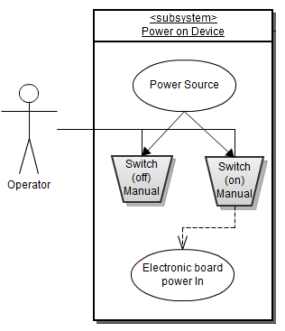
Figure 10-1 Use Case: Enable/disable power

10.2 User calibrates the product

10.2.1 Calibrate product: The actor shall be able to calibrate the product using a client application which is connected to the product via network connection. The sensors within the product require initial calibration to use and may require additional calibration after some time.

10.2.2 Actor(s): Operator
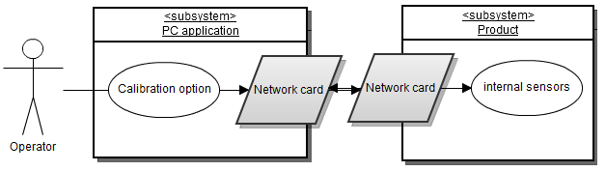
Figure 10-2 Use Case: Calibrate Product

10.3 User configures product

10.3.1 Configure product: The actor shall be able to configure the product through manipulating the bump detection algorithm. The user will be able to change the slide window parameter and bump threshold parameter prior to operation.

10.3.2 Actor(s): Operator
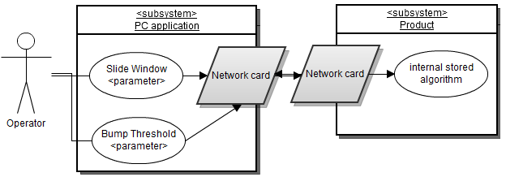
Figure 10-3 Use Case: Configure product

10.4 User retrieves data from the product

10.4.1 Data retrieval: The actor shall be able to retrieve operational data from the product through the PC application window. As the product is operating, it will send data back to the application for the user to view.

10.4.2 Actor(s): Operator
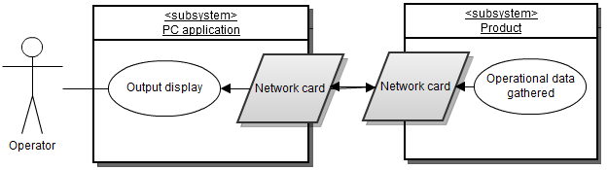
Figure 10-4 Use Case: Data retrieval

10.5 User cleans the product

10.5.1 Cleaning product: The actor shall be able to clean the product once the power has been turned off, the product dismounted, and disconnected. The actor then cleans any residual cement and/or dirt from the outer surface of the product.

10.5.2 Actor(s): Operator
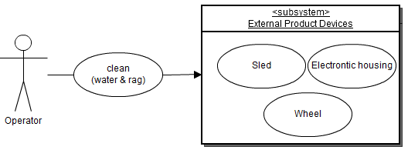
Figure 10-5 Use Case: Cleaning product

11. Feasibility Assessment
All sponsors and stakeholders have the right to know about the project before moving forward. They all want to make sure whether they have chosen the right project or not. Hence, it is very important to critically analyze the feasibility of successful and fulfillment of the requirements.
Feasibility analysis includes an assessment of the following six components: scope analysis, research completed/remaining; technical analysis, cost analysis, resource analysis, and schedule analysis. The assessment of our project feasibility requires considerable knowledge on various topics like road construction, circuit design, software application, and mechanical design.

11.1 Scope Analysis
The scope of work for all critical requirements is reasonable, and prototyping of these by the deadline date appears feasible. However, research will be required for this project in order to be successful. Our team realizes that careful consideration must be taken in this project because all previous projects failed. Our team also decided that we will focus most of our times on critical and high priority requirements in order to achieve the best possible outcome. If time permits, we will also focus on the medium and low priority requirements which we have few to none. Depending upon available time, low, medium, or both requirements might be considered as future items.

11.2 Research
It is important that we conduct research to assess the practicality/feasibility of achieving the requirements for this product. Our team conducted research to identify the feasibility of the project. Our team looked at previous documents and products. Our team also did some reverse engineering to determine the functionality of the System. Our sponsor, Dr. Walker, showed us two of the Sliding Profilers that failed to meet the requirements and explained why. Learning the mistakes from the previous project, out team decided it is quite feasible to make this project a success.
FAlso, the project is financially feasible because our sponsor, Dr. Walker, is willing to help us with any necessary costs. Also, we have the option to disassemble the previous projects design in order to obtain critical components that our project will need. Due to the possibility that the components may have failed, our team must make sure that the components are working and up to date before use. Hence, our project is financially sound. Most significant cost for our project might be the cost of materials for the platform.

11.3 Technical Analysis
Our project requires a technical ability in five major areas: (i) client application, (ii) Hardware design, (iii) Mechanical design of the platform, (iv) Server-Client communications, (v), and Algorithms.
Hardware design includes inclinometer, A/D convertor, distance encoder, power system, wireless access point, and an embedded PIC. The inclinometer will be used to measure the inclination of the Platform from a calibration point. A/D converter will be used to generate operational data from the raw data of the sensors. Distance encoder will be used to measure the travel distance of the Platform. Power system will be used to supply power to the all kinds of devices required in the project. Wireless access point will be required for server-client communications. Embedded PIC will be used to carry out a vast range of tasks such as computing raw data into usable data.
The client application has the ability to do many different tasks such as initiate the program, stop the program, calculation of bump detection, change of settings, and run the diagnostic tests. It also should have friendly user GUI that incorporates all of these functions and features.
Server-Client communications allows the operational data to be transferred to the client application. It also allows the data to be transferred to server from client application. The data collected by the measuring wheel and GPS are required to compute and detect bumps in concrete pavement. The computed data may be transferred back to server for storage purpose.
All previous projects failed because all of them didn’t have a proper mechanical design. Another important thing to consider while building this project is the weight of the product. It is extremely important that the product floats across the concrete pavement. Balsa wood, foam, or some kind of combinations might be an alternative used to reduce the weight of the product. More research will need to be conducted in order to reduce the surface area to weight ratio.
The algorithm is going to be a key part of this project. Since the product’s main purpose is to detect bumps in the concrete pavement, it is very important to come up with an efficient algorithms to detect bumps. Dr. Walker has already informed us of his bump detection algorithm which we can use or improve upon in order for our product to be more successful. One current problem his Dr. Walkers algorithm is that it lags by 5-6 seconds. Our team will need to conduct more research and testing to reduce this time lag.

11.4 Cost Analysis
Although our team has a maximum internal budget of $800, the cost aspect for this project should not be an issue. As this project has been funded by TxDOT, Dr. Walker is willing to donate the extra amount needed for our project. Also, some of the costs of the components like inclinometer, distance encoder are already excluded from the project cost because our team is going to re-use the working components from the previous projects. The major cost for our project will be the cost of materials needed to build the Platform. Other costs, like cost of client application, have yet to be decided. Other hardware components like power system, PIC chip, Ethernet might be provided by Dr. Walker. As a result, the cost will be drastically reduced if Dr. Walker has those components in his current inventory.
Our team has two possible cases of cost analysis. Case 1 assumes that partial components will be provided by Dr Walker and partial by Mr. O’Dell. The second case assumes that all the components will be provided by Mr. O’Dell. Components with low price of zero indicate that those components will be provided by Dr. Walker.
This table below shows the cost analysis of case 1.
Components | Low Price ($) | High Price ($)
Inclinometer | 0 | 900
Temperature Sensors | 0 | 5
Encoder | 0 | 5
Microcontroller Unit | 0 | 5
A/D Convertor | 0 | 250
GPS | 40 | 100
PCB + RS232 Interface | 15 | 35
Network chip | 10 | 45
SD Card | 3 | 20
Enclosure | 0 | 50
Platform | 40 | 150
Distance Wheel | 0 | 20
PC Client | 0 | 250
Total | 108 | 1585
Table 11-1 Case 1: Cost Analysis (Partial Dr Walker & Partial Mr. O’Dell)

This table below shows the cost analysis of case 2.
Components | Low Price ($) | High Price ($)
Inclinometer | 900 | 900
Temperature Sensors | 5 | 5
Encoder | 5 | 5
Microcontroller Unit | 5 | 5
A/D Convertor | 5 | 250
GPS | 40 | 100
PCB + RS232 Interface | 15 | 35
Network chip | 10 | 45
SD Card | 3 | 20
Enclosure | 30 | 50
Platform | 40 | 150
Distance Wheel | 15 | 20
PC Client | 150 | 250
Total | 1223 | 1585
Table 11-2 Case 2: Cost Analysis (Complete Mr. O’Dell)

In case our team doesn’t get the needed components from the previous project or Dr. Walker, our team should be able to get internal budget of $800 from Mr. O’Dell and the rest from TxDOT. Although the University has the patent for Sliding Profiler, TxDOT has been funding this project for couple of years.

11.5 Resource Analysis
As per the structure requirement of the team, our team consists of two computer engineers and two computer science engineers. Two computer engineers will be responsible for hardware design. Two computer science engineers will be responsible for the bump detection algorithm. All team members will be responsible for server-client communication. Since our team doesn’t have a software engineer, our team might have slight disadvantage on client application. However, this should not be a major risk that should be focused. Also, our team doesn’t have a mechanical engineer so; our team may have a slight disadvantage on coming up with a successful mechanical design. This is where research will be our biggest ally. All team members are sufficient in conducting research in the required missing topics.

11.6 Schedule Analysis
Estimation of size, effort, and schedule of the project is not quite easy. It requires the analysis of several estimation methods. The more effort and variety of approaches/methods used in estimating, the better our estimates will be. Also using ranges for estimates and gradually refining the ranges as the project progresses builds up the confidence of the customers. Hence, our team has tried to come up with various estimation methods.
Also, looking at the similar previous project will help us to make our estimates more accurate. Our team has looked at the schedule of previous team’s SDTT as well. The information was quite helpful for estimating size, effort and scheduling of the project.
Estimation of size and productivity
Software Project Size and Productivity Approach
Low Side High Side
(Aggressive) (Conservative)
Size Estimate 7500 LOC 9600 LOC
Productivity 375 LOC/PM 300 LOC/PM
Effort 20 PM 32 PM
Duration 6 months 8 months
Table 11-3 Software Project Size and Productivity Approach
Using McConnell Table 8-10 (p. 196), Nominal Schedule, System Product
Also using the equation of linear interpolation, we get
Duration 7.5 months 9.6 months

Rule of Thumb
(Duration = 3 x PM^{1/3})
Low Side High Side
(Aggressive) (Conservative)
3 x 20^{1/3} = 3 x 32^{1/3} =
Duration 8.14 (≅ 8) months 9.52 (≅9 1/2) months
Table 11-4 Rule of Thumb
Since, our team does not have a software engineer, it was decided that we will not use the function point with Jone’s First Order Schedule Estimation
CoCoMo
Basic CoCoMo Estimation Coefficients, based on project type/complexity:
Coefficient | a | b | c | d
Organic | 2.4 | 1.05 | 2.5 | 0.38
Semi-detached | 3.0 | 1.12 | 2.5 | 0.35
Embedded | 3.6 | 1.20 | 2.5 | 0.32

Table 11-5 CoCoMo – nominal, semi-detached

Low Side High Side
(Aggressive) (Conservative)
Effort - PM E = 3.0(7.5)^{1.12} E = 3.0(9.6)^{1.12}
E = a(SLOC)^{b} = 28.6 PM = 37.8 PM
Duration – months E = 2.5(28)^{.35} E = 2.5(38)^{.35}
D = c(E)^{d} = 8.1 months = 8.9 months
≅8 months ≅9 months

Comparison of various estimation methods
Aggressive Conservative
Size and Productivity 6 months 8 months
McConnell Tables 7 months 9 months
Rule of Thumb 8 months 9 months
CoCoMo 8 months 9 months
Function Points/Jones’s Not Used
Table 11-6 Comparison of various estimation methods
Sanity Test (Weiss & Wysocki, 1992)
E = (O + 4M + P) / 6, where O = optimistic, M = Nominal, P = Pessimistic
Therefore, our E = (6 + 32 + 9) / 6 = 47/6 = 7.8 months
All estimates above are our preliminary ranges. The estimates will be better as project progresses.

12. Future Items
The following requirements are items that may be implemented at a later date. These items currently extend beyond the schedule. These items additionally are not critical to the acceptance or performance of the System.

12. 1 The operator shall be able to run diagnostics test from client application

12.1.1 Requirement Description: The operator should be able to run a diagnostic test. Before using the System, it is important to know whether the System is working well or not.

12.1.2 Constraint: Time Limit

12. 2 The System shall have help option

12.2.1 Requirement Description: The System is quite expensive and might be quite complicated for some operators to use. Hence, the System shall have help option to improve customer experience.

12.2.2 Constraint: Time Limit

